Router-on-a-stick Configuration

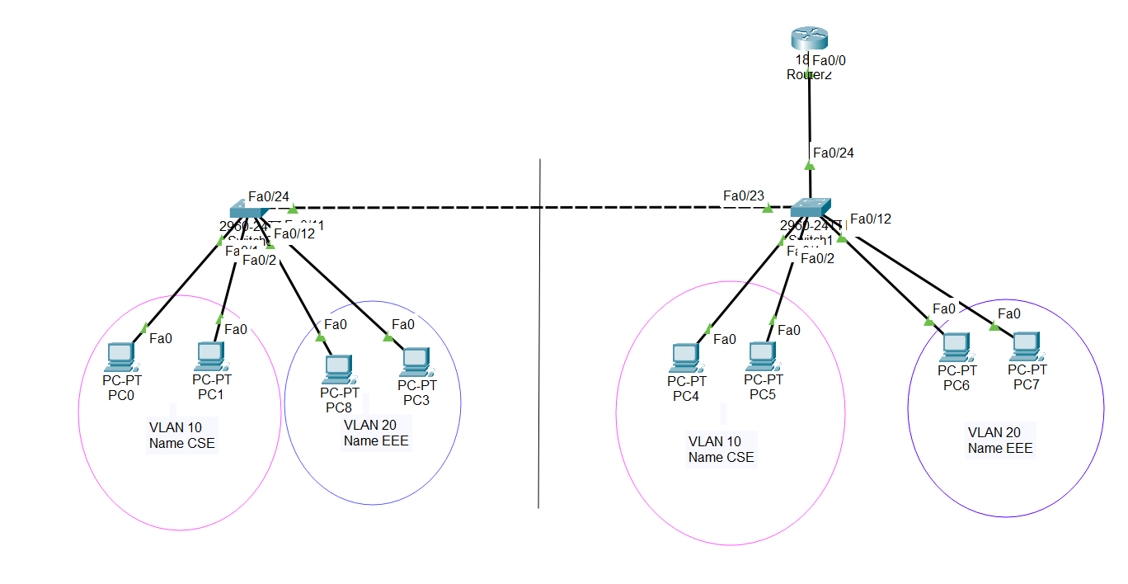

Fig 8.2: Router-on-a-stick Configured in Cisco Packet Tracer

